**CS673 Software Engineering** 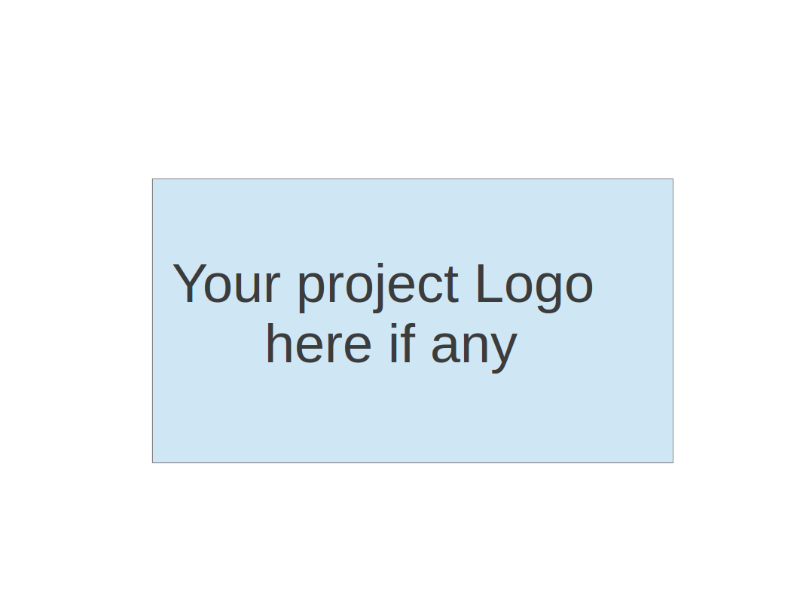

**Team 4 - Computer Science Project Portal**

**Tests Report**

|  |  |  |  |
| --- | --- | --- | --- |
| Team Member | Role(s) | Signature | Date |
| Zachary Kysar | Backup Team Leader and Requirements Leader | *Zak* | 12/11/2019 |
| Connor Richmond | Team Lead | *CR* | 12/11/2019 |
| Rattikan Dudley | Security Lead | *Rk* | 12/11/2019 |
| Molla Negash | Configuration management plan lead | *MN* | 12/11/2019 |
| Juan P Sanchez | Quality Lead | *JPS* | 12/12/2019 |
|  |  |  |  |
|  |  |  |  |
|  |  |  |  |

**Revision history**

|  |  |  |  |
| --- | --- | --- | --- |
| **Version** | **Author** | **Date** | **Change** |
| **1** | **RK** | **12/11/2019** | **Adding Test Report** |
| **2** | **JPS** | **12/11/2019** | **Adding first round of metrics. Coverage pending** |
| **3** | **JPS** | **12/12/2019** | **Code coverage metrics. Appendix and final review** |

Introduction

Test Summary

Tests Reports

Testing Metrics

References

Glossary

# Introduction

Computer Science Project Portal is a web based application purposed to provide project information among students and faculties. The system provides several features such as search, add ,delete project as long as user access control login system to identify user identity.

This document explains the various activities performed as part of the testing of computer project portal system application.

# Test Summary

**Testing Environment Tools:**

|  |  |
| --- | --- |
| Application URL : | <http://www.computerscienceprojectportal.com/> |
| Application Server: | 143.95.251.88 |
| IDE | Microsoft Visual Studio |
| Database | Microsoft SQL |
| Framework: | Nunit Framework  Nunit Testing Adapter  Selenium Framework |

**Testing Scope:**

1. **In Scope**

The functional testing units are in a scope of testing

* Log in
* Log out
* Faculty Profile
* Student Profile
* Add Project
* Delete Project
* Search Project
* Add Supervisee
* Delete Supervisee
* Edit faculty Profile
* Edit Student Profile

1. **Out Scope**

Performance Testing was not done for this application.

1. **Items Not Testes**

* Forget password
* Same username in the database system
* New username edit profile
* Project List Functionality
* Delete comment with foriegn key

# Tests Reports

In computer science project portal, we created test criteria based on

* Test ID
* Test Scenario
* Test Description
* Test Priority
* Test Step
* Precondition
* Postcondition
* Expected output
* Actual output
* Pass/Fail
* Bugs report

The following sheet is a test report which contains all information based on the above criteria. It covered both manual and automated testing since from the iteration 3.

[Test Report](https://docs.google.com/spreadsheets/d/1fokpNA7FanNIHHsMrEw2r-_6Afx2k6-Dl5a9jFSDSqk/edit?folder=1hF303Is0v1mzjxUtKZvsGmyiIMgzIZz8#gid=0)

# Testing Metrics

Test Coverage: test coverage is a measure used to describe the degree to which the [source code](https://en.wikipedia.org/wiki/Source_code) of a [program](https://en.wikipedia.org/wiki/Computer_program) is executed when a particular [test suite](https://en.wikipedia.org/wiki/Test_suite) runs. A program with high test coverage, measured as a percentage, has had more of its source code executed during testing, which suggests it has a lower chance of containing undetected [software bugs](https://en.wikipedia.org/wiki/Software_bug) compared to a program with low test coverage

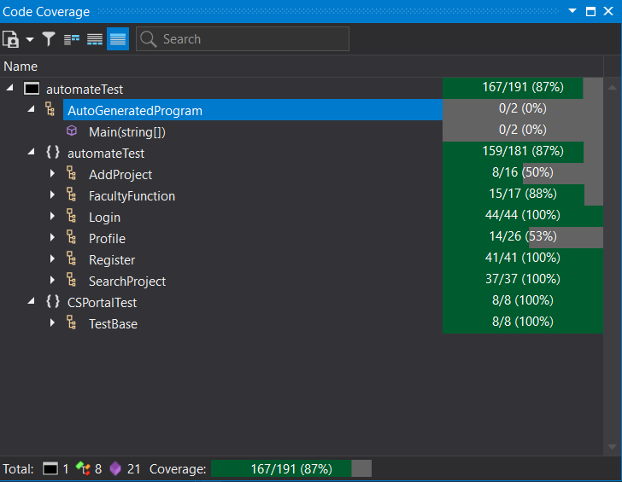

Code Coverage Summary - Dev Express

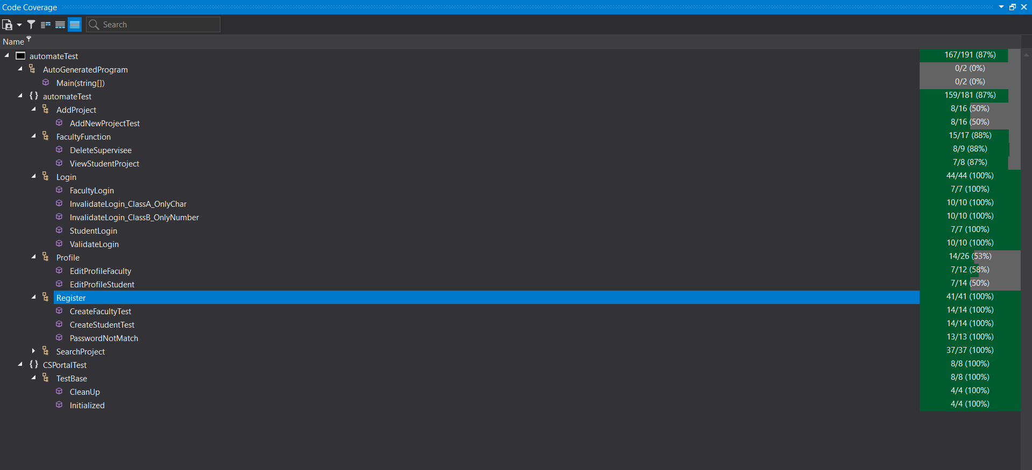

Code Coverage Visual Studio - Dev Expres

|  |  |  |  |  |  |  |  |  |
| --- | --- | --- | --- | --- | --- | --- | --- | --- |
| **METRIC** | **Unit** | **Type** | **0** | **1** | **2** | **3** | **4** | **5** |
| Product Complexity | KLOC | Product | 500 | 1200 | 2065 | 2066 | 2078 | 2089 |
| Defect Density | # Defects / KLOC | Product | 0 | 0 | 0.000484261 | 0.000968054 | 0.000962463 | 0.004308281 |
| Defect Count | # Defects | Product | 0 | 0 | 1 | 2 | 2 | 9 |
| Test Cases Count | # Test cases total | Process | 0 | 0 | 1 | 5 | 3 | 18 |
| Test Case Pass Rate | # Passed / # Total | Process | 0 | 0 | 1 | 5 | 3 | 18 |

Metrics Testing By Iteration

# References

* <https://www.c-sharpcorner.com/article/unit-testing-with-selenium-webdriver/>
* <https://www.softwaretestinghelp.com/test-execution-report/>
* <https://www.softwaretestinghelp.com/test-summary-report-template-download-sample/>
* <https://documentation.devexpress.com/CodeRushForRoslyn/115735/Unit-Testing-Assistance/Code-Coverage-Calculation>
* <https://www.guru99.com/test-coverage-in-software-testing.html>

# Appendix

**Coverage Report HTML**

<!DOCTYPE html><html>

<head>

<META http-equiv="Content-Type" content="text/html; charset=utf-8">

<link href="https://netdna.bootstrapcdn.com/bootstrap/3.2.0/css/bootstrap.min.css" rel="stylesheet"><script type="text/javascript" src="https://ajax.googleapis.com/ajax/libs/jquery/2.0.2/jquery.min.js"></script><script type="text/javascript" src="https://netdna.bootstrapcdn.com/bootstrap/3.2.0/js/bootstrap.min.js"></script><style>

.time_display {

margin-left: 5px;

}

.report-header {

line-height: 3;

border: 2px solid rgb(221, 221, 221);

}

.report-row {

line-height: 2.5;

border-bottom: 1px solid rgb(221, 221, 221);

border-left: 1px solid rgb(221, 221, 221);

border-right: 1px solid rgb(221, 221, 221);

}

.scope_name {

margin-left: 5px;

}

.progress {

border-radius: 1px;

height: 10px;

margin-top: 12px;

margin-bottom: 12px;

}

</style>

</head>

<body>

<div class="container">

<div class="row">

<div class="col-md-8">

<h1>Code Coverage Report</h1>

</div>

<div class="col-md-2"></div>

</div>

<div class="panel panel-default">

<div class="panel-body">

<div class="row">

<div class="col-md-2"><strong>Date:</strong></div>

<div class="col-md-4"><strong>2019-12-12</strong><strong class="time_display">16:36</strong></div>

</div>

<div class="row">

<div class="col-md-6">

<div class="row">

<div class="col-md-2"><strong>Projects:</strong></div>

<div class="col-md-2"><strong>1</strong></div>

</div>

<div class="row">

<div class="col-md-2"><strong>Types:</strong></div>

<div class="col-md-2"><strong>7</strong></div>

</div>

<div class="row">

<div class="col-md-2"><strong>Methods:</strong></div>

<div class="col-md-2"><strong>20</strong></div>

</div>

</div>

<div class="col-md-6">

<div class="row">

<div class="col-md-2"><strong>Coverage:</strong></div>

<div class="col-md-4"><strong>87%</strong></div>

</div>

<div class="row">

<div class="col-md-2"><strong>Covered:</strong></div>

<div class="col-md-4"><strong>167</strong></div>

</div>

<div class="row">

<div class="col-md-2"><strong>Total:</strong></div>

<div class="col-md-4"><strong>191</strong></div>

</div>

</div>

</div>

<div class="row">

<div class="col-md-2"><strong>Legend:</strong></div>

<div class="col-md-2"><span class="label label-danger">Low: 0 to 15%</span></div>

<div class="col-md-2"><span class="label label-warning">Medium: 16 to 50%</span></div>

<div class="col-md-2"><span class="label label-success">High: 51 to 100%</span></div>

</div>

</div>

</div>

<div class="row report-header">

<div class="col-md-8 text-center"><strong>Scope</strong></div>

<div class="col-md-4 text-center"><strong>Coverage</strong></div>

</div>

<div class="row report-row">

<div class="col-md-8">

<div style="margin-left:0px"><button class="btn btn-default btn-xs accordion-toggle" data-toggle="collapse" data-target="#collapseID0EG"><span class="glyphicon glyphicon-plus-sign"></span></button><span class="scope_name">automateTest</span></div>

</div>

<div class="col-md-1">

<div class="progress">

<div class="progress-bar progress-bar-success" role="progressbar" aria-valuenow="0.87434554973821987" aria-valuemin="0" aria-valuemax="100" style="width: 87%"></div>

</div>

</div>

<div class="col-md-1 text-center bg-success">87%</div>

<div class="col-md-2 text-center bg-success">167 / 191</div>

</div>

<div id="collapseID0EG" class="accordion-body collapse">

<div class="row report-row">

<div class="col-md-8">

<div style="margin-left:40px"><button class="btn btn-default btn-xs accordion-toggle" data-toggle="collapse" data-target="#collapseID0EM"><span class="glyphicon glyphicon-plus-sign"></span></button><span class="scope_name">AutoGeneratedProgram</span></div>

</div>

<div class="col-md-1">

<div class="progress">

<div class="progress-bar progress-bar-danger" role="progressbar" aria-valuenow="0" aria-valuemin="0" aria-valuemax="100" style="width: 0%"></div>

</div>

</div>

<div class="col-md-1 text-center bg-danger">0%</div>

<div class="col-md-2 text-center bg-danger">0 / 2</div>

</div>

<div id="collapseID0EM" class="accordion-body collapse">

<div class="row report-row">

<div class="col-md-8">

<div style="margin-left: 60px; line-height: 2">Main(string[])</div>

</div>

<div class="col-md-1">

<div class="progress">

<div class="progress-bar progress-bar-danger" role="progressbar" aria-valuenow="0" aria-valuemin="0" aria-valuemax="100" style="width: 0%"></div>

</div>

</div>

<div class="col-md-1 text-center bg-danger">0%</div>

<div class="col-md-2 text-center bg-danger">0 / 2</div>

</div>

</div>

<div class="row report-row">

<div class="col-md-8">

<div style="margin-left:20px"><button class="btn btn-default btn-xs accordion-toggle" data-toggle="collapse" data-target="#collapseID0EV"><span class="glyphicon glyphicon-plus-sign"></span></button><span class="scope_name">automateTest</span></div>

</div>

<div class="col-md-1">

<div class="progress">

<div class="progress-bar progress-bar-success" role="progressbar" aria-valuenow="0.87845303867403313" aria-valuemin="0" aria-valuemax="100" style="width: 88%"></div>

</div>

</div>

<div class="col-md-1 text-center bg-success">88%</div>

<div class="col-md-2 text-center bg-success">159 / 181</div>

</div>

<div id="collapseID0EV" class="accordion-body collapse">

<div class="row report-row">

<div class="col-md-8">

<div style="margin-left:40px"><button class="btn btn-default btn-xs accordion-toggle" data-toggle="collapse" data-target="#collapseID0E2"><span class="glyphicon glyphicon-plus-sign"></span></button><span class="scope_name">AddProject</span></div>

</div>

<div class="col-md-1">

<div class="progress">

<div class="progress-bar progress-bar-warning" role="progressbar" aria-valuenow="0.5" aria-valuemin="0" aria-valuemax="100" style="width: 50%"></div>

</div>

</div>

<div class="col-md-1 text-center bg-warning">50%</div>

<div class="col-md-2 text-center bg-warning">8 / 16</div>

</div>

<div id="collapseID0E2" class="accordion-body collapse">

<div class="row report-row">

<div class="col-md-8">

<div style="margin-left: 60px; line-height: 2">AddNewProjectTest</div>

</div>

<div class="col-md-1">

<div class="progress">

<div class="progress-bar progress-bar-warning" role="progressbar" aria-valuenow="0.5" aria-valuemin="0" aria-valuemax="100" style="width: 50%"></div>

</div>

</div>

<div class="col-md-1 text-center bg-warning">50%</div>

<div class="col-md-2 text-center bg-warning">8 / 16</div>

</div>

</div>

<div class="row report-row">

<div class="col-md-8">

<div style="margin-left:40px"><button class="btn btn-default btn-xs accordion-toggle" data-toggle="collapse" data-target="#collapseID0EIB"><span class="glyphicon glyphicon-plus-sign"></span></button><span class="scope_name">FacultyFunction</span></div>

</div>

<div class="col-md-1">

<div class="progress">

<div class="progress-bar progress-bar-success" role="progressbar" aria-valuenow="0.88235294117647056" aria-valuemin="0" aria-valuemax="100" style="width: 88%"></div>

</div>

</div>

<div class="col-md-1 text-center bg-success">88%</div>

<div class="col-md-2 text-center bg-success">15 / 17</div>

</div>

<div id="collapseID0EIB" class="accordion-body collapse">

<div class="row report-row">

<div class="col-md-8">

<div style="margin-left: 60px; line-height: 2">DeleteSupervisee</div>

</div>

<div class="col-md-1">

<div class="progress">

<div class="progress-bar progress-bar-success" role="progressbar" aria-valuenow="0.88888888888888884" aria-valuemin="0" aria-valuemax="100" style="width: 89%"></div>

</div>

</div>

<div class="col-md-1 text-center bg-success">89%</div>

<div class="col-md-2 text-center bg-success">8 / 9</div>

</div>

<div class="row report-row">

<div class="col-md-8">

<div style="margin-left: 60px; line-height: 2">ViewStudentProject</div>

</div>

<div class="col-md-1">

<div class="progress">

<div class="progress-bar progress-bar-success" role="progressbar" aria-valuenow="0.875" aria-valuemin="0" aria-valuemax="100" style="width: 88%"></div>

</div>

</div>

<div class="col-md-1 text-center bg-success">88%</div>

<div class="col-md-2 text-center bg-success">7 / 8</div>

</div>

</div>

<div class="row report-row">

<div class="col-md-8">

<div style="margin-left:40px"><button class="btn btn-default btn-xs accordion-toggle" data-toggle="collapse" data-target="#collapseID0E2B"><span class="glyphicon glyphicon-plus-sign"></span></button><span class="scope_name">Login</span></div>

</div>

<div class="col-md-1">

<div class="progress">

<div class="progress-bar progress-bar-success" role="progressbar" aria-valuenow="1" aria-valuemin="0" aria-valuemax="100" style="width: 100%"></div>

</div>

</div>

<div class="col-md-1 text-center bg-success">100%</div>

<div class="col-md-2 text-center bg-success">44 / 44</div>

</div>

<div id="collapseID0E2B" class="accordion-body collapse">

<div class="row report-row">

<div class="col-md-8">

<div style="margin-left: 60px; line-height: 2">FacultyLogin</div>

</div>

<div class="col-md-1">

<div class="progress">

<div class="progress-bar progress-bar-success" role="progressbar" aria-valuenow="1" aria-valuemin="0" aria-valuemax="100" style="width: 100%"></div>

</div>

</div>

<div class="col-md-1 text-center bg-success">100%</div>

<div class="col-md-2 text-center bg-success">7 / 7</div>

</div>

<div class="row report-row">

<div class="col-md-8">

<div style="margin-left: 60px; line-height: 2">InvalidateLogin_ClassA_OnlyChar</div>

</div>

<div class="col-md-1">

<div class="progress">

<div class="progress-bar progress-bar-success" role="progressbar" aria-valuenow="1" aria-valuemin="0" aria-valuemax="100" style="width: 100%"></div>

</div>

</div>

<div class="col-md-1 text-center bg-success">100%</div>

<div class="col-md-2 text-center bg-success">10 / 10</div>

</div>

<div class="row report-row">

<div class="col-md-8">

<div style="margin-left: 60px; line-height: 2">InvalidateLogin_ClassB_OnlyNumber</div>

</div>

<div class="col-md-1">

<div class="progress">

<div class="progress-bar progress-bar-success" role="progressbar" aria-valuenow="1" aria-valuemin="0" aria-valuemax="100" style="width: 100%"></div>

</div>

</div>

<div class="col-md-1 text-center bg-success">100%</div>

<div class="col-md-2 text-center bg-success">10 / 10</div>

</div>

<div class="row report-row">

<div class="col-md-8">

<div style="margin-left: 60px; line-height: 2">StudentLogin</div>

</div>

<div class="col-md-1">

<div class="progress">

<div class="progress-bar progress-bar-success" role="progressbar" aria-valuenow="1" aria-valuemin="0" aria-valuemax="100" style="width: 100%"></div>

</div>

</div>

<div class="col-md-1 text-center bg-success">100%</div>

<div class="col-md-2 text-center bg-success">7 / 7</div>

</div>

<div class="row report-row">

<div class="col-md-8">

<div style="margin-left: 60px; line-height: 2">ValidateLogin</div>

</div>

<div class="col-md-1">

<div class="progress">

<div class="progress-bar progress-bar-success" role="progressbar" aria-valuenow="1" aria-valuemin="0" aria-valuemax="100" style="width: 100%"></div>

</div>

</div>

<div class="col-md-1 text-center bg-success">100%</div>

<div class="col-md-2 text-center bg-success">10 / 10</div>

</div>

</div>

<div class="row report-row">

<div class="col-md-8">

<div style="margin-left:40px"><button class="btn btn-default btn-xs accordion-toggle" data-toggle="collapse" data-target="#collapseID0EAD"><span class="glyphicon glyphicon-plus-sign"></span></button><span class="scope_name">Profile</span></div>

</div>

<div class="col-md-1">

<div class="progress">

<div class="progress-bar progress-bar-success" role="progressbar" aria-valuenow="0.53846153846153844" aria-valuemin="0" aria-valuemax="100" style="width: 54%"></div>

</div>

</div>

<div class="col-md-1 text-center bg-success">54%</div>

<div class="col-md-2 text-center bg-success">14 / 26</div>

</div>

<div id="collapseID0EAD" class="accordion-body collapse">

<div class="row report-row">

<div class="col-md-8">

<div style="margin-left: 60px; line-height: 2">EditProfileFaculty</div>

</div>

<div class="col-md-1">

<div class="progress">

<div class="progress-bar progress-bar-success" role="progressbar" aria-valuenow="0.58333333333333337" aria-valuemin="0" aria-valuemax="100" style="width: 58%"></div>

</div>

</div>

<div class="col-md-1 text-center bg-success">58%</div>

<div class="col-md-2 text-center bg-success">7 / 12</div>

</div>

<div class="row report-row">

<div class="col-md-8">

<div style="margin-left: 60px; line-height: 2">EditProfileStudent</div>

</div>

<div class="col-md-1">

<div class="progress">

<div class="progress-bar progress-bar-warning" role="progressbar" aria-valuenow="0.5" aria-valuemin="0" aria-valuemax="100" style="width: 50%"></div>

</div>

</div>

<div class="col-md-1 text-center bg-warning">50%</div>

<div class="col-md-2 text-center bg-warning">7 / 14</div>

</div>

</div>

<div class="row report-row">

<div class="col-md-8">

<div style="margin-left:40px"><button class="btn btn-default btn-xs accordion-toggle" data-toggle="collapse" data-target="#collapseID0ETD"><span class="glyphicon glyphicon-plus-sign"></span></button><span class="scope_name">Register</span></div>

</div>

<div class="col-md-1">

<div class="progress">

<div class="progress-bar progress-bar-success" role="progressbar" aria-valuenow="1" aria-valuemin="0" aria-valuemax="100" style="width: 100%"></div>

</div>

</div>

<div class="col-md-1 text-center bg-success">100%</div>

<div class="col-md-2 text-center bg-success">41 / 41</div>

</div>

<div id="collapseID0ETD" class="accordion-body collapse">

<div class="row report-row">

<div class="col-md-8">

<div style="margin-left: 60px; line-height: 2">CreateFacultyTest</div>

</div>

<div class="col-md-1">

<div class="progress">

<div class="progress-bar progress-bar-success" role="progressbar" aria-valuenow="1" aria-valuemin="0" aria-valuemax="100" style="width: 100%"></div>

</div>

</div>

<div class="col-md-1 text-center bg-success">100%</div>

<div class="col-md-2 text-center bg-success">14 / 14</div>

</div>

<div class="row report-row">

<div class="col-md-8">

<div style="margin-left: 60px; line-height: 2">CreateStudentTest</div>

</div>

<div class="col-md-1">

<div class="progress">

<div class="progress-bar progress-bar-success" role="progressbar" aria-valuenow="1" aria-valuemin="0" aria-valuemax="100" style="width: 100%"></div>

</div>

</div>

<div class="col-md-1 text-center bg-success">100%</div>

<div class="col-md-2 text-center bg-success">14 / 14</div>

</div>

<div class="row report-row">

<div class="col-md-8">

<div style="margin-left: 60px; line-height: 2">PasswordNotMatch</div>

</div>

<div class="col-md-1">

<div class="progress">

<div class="progress-bar progress-bar-success" role="progressbar" aria-valuenow="1" aria-valuemin="0" aria-valuemax="100" style="width: 100%"></div>

</div>

</div>

<div class="col-md-1 text-center bg-success">100%</div>

<div class="col-md-2 text-center bg-success">13 / 13</div>

</div>

</div>

<div class="row report-row">

<div class="col-md-8">

<div style="margin-left:40px"><button class="btn btn-default btn-xs accordion-toggle" data-toggle="collapse" data-target="#collapseID0EME"><span class="glyphicon glyphicon-plus-sign"></span></button><span class="scope_name">SearchProject</span></div>

</div>

<div class="col-md-1">

<div class="progress">

<div class="progress-bar progress-bar-success" role="progressbar" aria-valuenow="1" aria-valuemin="0" aria-valuemax="100" style="width: 100%"></div>

</div>

</div>

<div class="col-md-1 text-center bg-success">100%</div>

<div class="col-md-2 text-center bg-success">37 / 37</div>

</div>

<div id="collapseID0EME" class="accordion-body collapse">

<div class="row report-row">

<div class="col-md-8">

<div style="margin-left: 60px; line-height: 2">AddCommentTest</div>

</div>

<div class="col-md-1">

<div class="progress">

<div class="progress-bar progress-bar-success" role="progressbar" aria-valuenow="1" aria-valuemin="0" aria-valuemax="100" style="width: 100%"></div>

</div>

</div>

<div class="col-md-1 text-center bg-success">100%</div>

<div class="col-md-2 text-center bg-success">9 / 9</div>

</div>

<div class="row report-row">

<div class="col-md-8">

<div style="margin-left: 60px; line-height: 2">FindProjectTestAuthor</div>

</div>

<div class="col-md-1">

<div class="progress">

<div class="progress-bar progress-bar-success" role="progressbar" aria-valuenow="1" aria-valuemin="0" aria-valuemax="100" style="width: 100%"></div>

</div>

</div>

<div class="col-md-1 text-center bg-success">100%</div>

<div class="col-md-2 text-center bg-success">7 / 7</div>

</div>

<div class="row report-row">

<div class="col-md-8">

<div style="margin-left: 60px; line-height: 2">FindProjectTestName</div>

</div>

<div class="col-md-1">

<div class="progress">

<div class="progress-bar progress-bar-success" role="progressbar" aria-valuenow="1" aria-valuemin="0" aria-valuemax="100" style="width: 100%"></div>

</div>

</div>

<div class="col-md-1 text-center bg-success">100%</div>

<div class="col-md-2 text-center bg-success">7 / 7</div>

</div>

<div class="row report-row">

<div class="col-md-8">

<div style="margin-left: 60px; line-height: 2">findProjectTestTag</div>

</div>

<div class="col-md-1">

<div class="progress">

<div class="progress-bar progress-bar-success" role="progressbar" aria-valuenow="1" aria-valuemin="0" aria-valuemax="100" style="width: 100%"></div>

</div>

</div>

<div class="col-md-1 text-center bg-success">100%</div>

<div class="col-md-2 text-center bg-success">7 / 7</div>

</div>

<div class="row report-row">

<div class="col-md-8">

<div style="margin-left: 60px; line-height: 2">FindProjectTestTag</div>

</div>

<div class="col-md-1">

<div class="progress">

<div class="progress-bar progress-bar-success" role="progressbar" aria-valuenow="1" aria-valuemin="0" aria-valuemax="100" style="width: 100%"></div>

</div>

</div>

<div class="col-md-1 text-center bg-success">100%</div>

<div class="col-md-2 text-center bg-success">7 / 7</div>

</div>

</div>

</div>

<div class="row report-row">

<div class="col-md-8">

<div style="margin-left:20px"><button class="btn btn-default btn-xs accordion-toggle" data-toggle="collapse" data-target="#collapseID0ESF"><span class="glyphicon glyphicon-plus-sign"></span></button><span class="scope_name">CSPortalTest</span></div>

</div>

<div class="col-md-1">

<div class="progress">

<div class="progress-bar progress-bar-success" role="progressbar" aria-valuenow="1" aria-valuemin="0" aria-valuemax="100" style="width: 100%"></div>

</div>

</div>

<div class="col-md-1 text-center bg-success">100%</div>

<div class="col-md-2 text-center bg-success">8 / 8</div>

</div>

<div id="collapseID0ESF" class="accordion-body collapse">

<div class="row report-row">

<div class="col-md-8">

<div style="margin-left:40px"><button class="btn btn-default btn-xs accordion-toggle" data-toggle="collapse" data-target="#collapseID0EYF"><span class="glyphicon glyphicon-plus-sign"></span></button><span class="scope_name">TestBase</span></div>

</div>

<div class="col-md-1">

<div class="progress">

<div class="progress-bar progress-bar-success" role="progressbar" aria-valuenow="1" aria-valuemin="0" aria-valuemax="100" style="width: 100%"></div>

</div>

</div>

<div class="col-md-1 text-center bg-success">100%</div>

<div class="col-md-2 text-center bg-success">8 / 8</div>

</div>

<div id="collapseID0EYF" class="accordion-body collapse">

<div class="row report-row">

<div class="col-md-8">

<div style="margin-left: 60px; line-height: 2">CleanUp</div>

</div>

<div class="col-md-1">

<div class="progress">

<div class="progress-bar progress-bar-success" role="progressbar" aria-valuenow="1" aria-valuemin="0" aria-valuemax="100" style="width: 100%"></div>

</div>

</div>

<div class="col-md-1 text-center bg-success">100%</div>

<div class="col-md-2 text-center bg-success">4 / 4</div>

</div>

<div class="row report-row">

<div class="col-md-8">

<div style="margin-left: 60px; line-height: 2">Initialized</div>

</div>

<div class="col-md-1">

<div class="progress">

<div class="progress-bar progress-bar-success" role="progressbar" aria-valuenow="1" aria-valuemin="0" aria-valuemax="100" style="width: 100%"></div>

</div>

</div>

<div class="col-md-1 text-center bg-success">100%</div>

<div class="col-md-2 text-center bg-success">4 / 4</div>

</div>

</div>

</div>

</div>

</div>

</body>

</html>